LandAid logo guidance

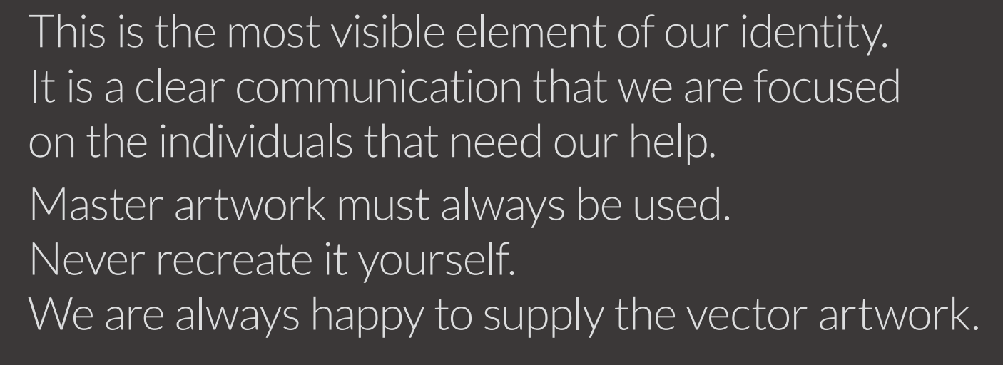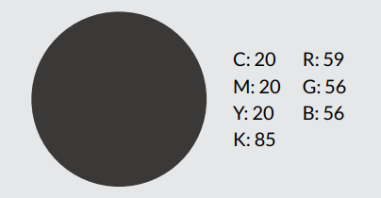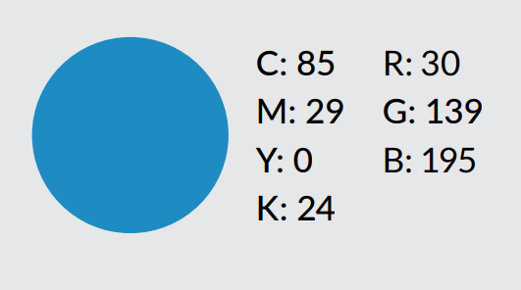

Depending on your relationship with LandAid you will have access to one of the below logos. This can be used across your varying communications channels (including web, social, email etc…) to show your relationship with LandAid.
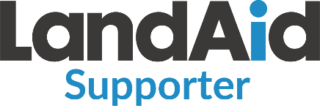
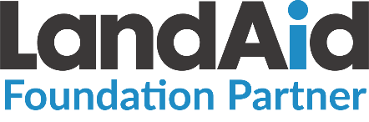
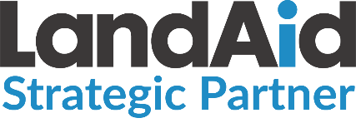

For partner and supporter organistaions, we also have a ‘supporting’ and ‘in partnership with’ logo lock-up available to use. Each partner should receive this as part of their welcome email. If you do not have access to these logos, please ask your Account Manager or main LandAid contact.
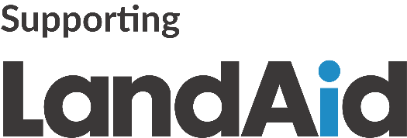
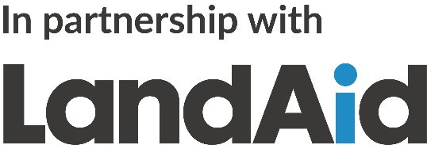

Spacing
Our logo has an exclusion zone to keep it legible and ensure it clearly stands out. It must always be displayed with a clear space on all sides. The height of the ‘L’ determines the minimum size of this space.
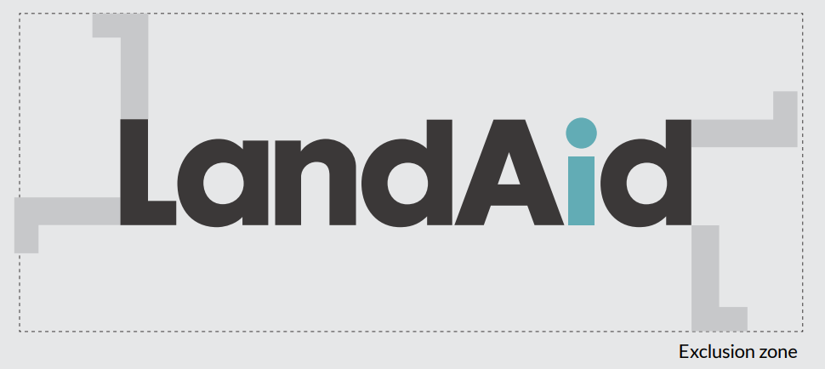
Size
The minimum size requirement (width) is:
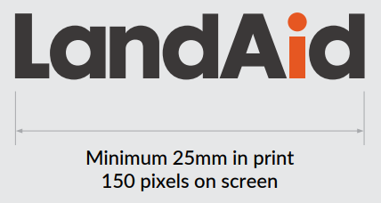

Merchandise
LandAid are very happy for partner and supporter organisations to use the LandAid logo across physical merchandise. However, please ensure that any designs are forwarded to your main LandAid contact for sign off from the Communications team before going to print or production.

